1 30 17_catic-logo_no-tag_Horizontal_email_blue-line

**101 Corporate Place, Rocky Hill, CT 06067**

ENERGY PROJECT – SPECIAL MEASURE OF LOSS ENDORSEMENT – LOAN POLICY

Attached to Loan Policy No.

The Company agrees that, for purposes of determining the extent of liability of the Company for loss or damage by reason of any defect, lien, encumbrance or other matter insured against by this policy ("Defect"), Condition 8(a)(iii) shall be replaced in its entirety to read as follows:

"(iii) the difference between (A) the value of the Title as insured without the Defect, taking into consideration, at the time notice of claim is given to the Company, the use or intended use of the Land as a single integrated site for the Project Facility, and (B) the value of the Title subject to the Defect, taking into consideration the factors set forth in (A) above.”

This endorsement is issued as part of the policy. Except as it expressly states, it does not (i) modify any of the terms and provisions of the policy, (ii) modify any prior endorsements, (iii) extend the Date of Policy, or (iv) increase the Amount of Insurance. To the extent a provision of the policy or a previous endorsement is inconsistent with an express provision of this endorsement, this endorsement controls. Otherwise, this endorsement is subject to all of the terms and provisions of the policy and of any prior endorsements.

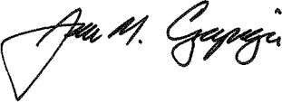CATIC

JAMES M. CZAPIGA, PRESIDENT