ALTA 48.1 ENDORSEMENT – TRIBAL LIMITED WAIVER AND CONSENT AGREEMENT

**This endorsement is issued as part of Policy Number issued by CATIC**

1. The Insured has executed a limited waiver of sovereign immunity and consent agreement (the “Agreement”) for the benefit of the Company, entitled , executed by

, and dated .

1. The Company has issued the policy in reliance on the Agreement, and the Agreement is incorporated by reference in the policy as if the Agreement were set out in full in this endorsement.

This endorsement is issued as part of the policy. Except as it expressly states, it does not (i) modify any of the terms and provisions of the policy, (ii) modify any prior endorsements, (iii) extend the Date of Policy, or (iv) increase the Amount of Insurance. To the extent a provision of the policy or a previous endorsement is inconsistent with an express provision of this endorsement, this endorsement controls. Otherwise, this endorsement is subject to all of the terms and provisions of the policy and of any prior endorsements.

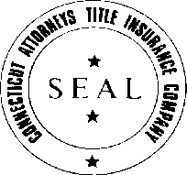CATIC

JAMES M. CZAPIGA, PRESIDENT